**Detecting Deep Fakes: A Deep Learning Approach**

*A Mini Project Report Submitted in the Partial Fulfillment of the Requirements for the Award of the Degree of*

### BACHELOR OF TECHNOLOGY IN

### COMPUTER SCIENCE AND ENGINEERING (AI&ML)

#### Submitted by

### A SUMETH KUMAR 21881A6667

### CHAVALI SAI SREEKAR 21881A6675 A MAHARSHI 22885A6608

### SUPERVISOR

**Mrs. Vijaylaxmi Bhure**

#### AssistantProfessor

#### Department of Computer Science and Engineering (AI &ML)



#### April, 2024



#### Department of Computer Science and Engineering (AI&ML)

**CERTIFICATE**

This is to certify that the project titled **MEASURING NETWORK SE- CURITY USING ATTACK GRAPHS** is carried out by

### A SUMETH KUMAR 21881A6667

### CHAVALI SAI SREEKAR 21881A6675 A MAHARSHI 22885A6608

in partial fulfillment of the requirements for the award of the degree of **Bachelor of Technology** in **Computer Science and Engineering (AI&ML)** during the year 2023-24.

#### Signature of the Supervisor Signature of the HOD

#### Mrs. Vijaylaxmi Bhure Dr M.A.Jabbar

#### Assistant Professor Professor& Head of the Dept

#### Dept of CSE(AI&ML) Dept of CSE(AI&ML)

Kacharam (V), Shamshabad (M), Ranga Reddy (Dist.)–501218, Hyderabad, T.S. Ph: 08413-253335, 253201, Fax: 08413-253482, [www.vardhaman.org](http://www.vardhaman.org/)

**Acknowledgement**

The satisfaction that accompanies the successful completion of the task would be put incomplete without the mention of the people who made it possible, whose constant guidance and encouragement crown all the efforts with success.

We wish to express our deep sense of gratitude to **Mrs. Vijaylaxmi Bhure**

, Assistant Professor and Project Supervisor, Department of CSE(AI&ML), Vardhaman College of Engineering, for her able guidance and useful sugges- tions, which helped us in completing the project in time.

We are particularly thankful to **Dr M.A.Jabbar**, the Head of the De- partment, Department of CSE(AI&ML), his guidance, intense support and encouragement, which helped us to mould our project into a successful one.

We show gratitude to our honorable Principal **Dr. J.V.R. Ravindra**, for providing all facilities and support.

We avail this opportunity to express our deep sense of gratitude and heart- ful thanks to **Dr. Teegala Vijender Reddy**, Chairman and **Sri Teegala Upender Reddy**, Secretary of VCE, for providing a congenial atmosphere to complete this project successfully.

We also thank all the staff members of Electronics and Communication Engineering department for their valuable support and generous advice. Finally thanks to all our friends and family members for their continuous support and enthusiastic help.

### A SUMETH KUMAR

### CHAVALI SAI SREEKAR

### A MAHARSHI

**Abstract**

Deep fake technology, powered by advanced machine learning algorithms, poses a significant challenge to the authenticity and integrity of multimedia content. These synthetic media productions, often generated using generative adversarial networks or autoencoder architectures, exhibit convincing simulations of human faces and behaviors. To counter this, deep fake detection has evolved through various methodologies, including forensic analysis, behavioral cues scrutiny, and deep learning-based classification. Attention mechanisms, inspired by human visual perception, can be a promising avenue for enhancing detection. Existing attention mechanisms have been integrated into deep fake detection pipelines, but novel advancements in attention mechanisms are necessary to overcome the evolving sophistication of deep fakes. These could involve integrating self-attention networks, spatiotemporal attention mechanisms, attention-based explanations, and fusion of attention mechanisms with other modalities like audio and text. Additionally, reinforcement learning techniques could be augmented to adapt to evolving deep fake generation techniques.

**Keywords**: Deep fake technology, Machine learning algorithms, Generative adversarial networks, Autoencoder architectures, Multimedia content, Synthetic media productions, Deep fake detection, Attention mechanisms, Spatiotemporal attention mechanisms, Reinforcement learning

**Table of Contents**

#### Title Page No.

|  |  |
| --- | --- |
| **Acknowledgement**. . . . . . . . . . . . . . . . . . . . . . . . . . . . . . . | i |
| **Abstract**. . . . . . . . . . . . . . . . . . . . . . . . . . . . . . . . . . . . . | ii |
| **List of Tables**. . . . . . . . . . . . . . . . . . . . . . . . . . . . . . . . . . | v |
| **List of Figures**. . . . . . . . . . . . . . . . . . . . . . . . . . . . . . . . . | vi |
| **Abbreviations**. . . . . . . . . . . . . . . . . . . . . . . . . . . . . . . . . . | vi |
| **CHAPTER 1** **Introduction**. . . . . . . . . . . . . . . . . . . . . . . . | 1 |
| 1.1 Background . . . . . . . . . . . . . . . . . . . . . . . . . . . . . . . | 1 |
| 1.1.1 Network Security . . . . . . . . . . . . . . . . . . . . . . . . | 1 |
| 1.1.2 Attack Graphs . . . . . . . . . . . . . . . . . . . . . . . . . | 2 |
| 1.2 Motivation . . . . . . . . . . . . . . . . . . . . . . . . . . . . . . . . | 5 |
| 1.3 Scope . . . . . . . . . . . . . . . . . . . . . . . . . . . . . . . . . . | 5 |
| 1.4 Objectives . . . . . . . . . . . . . . . . . . . . . . . . . . . . . . . . | 6 |
| **CHAPTER 2** **Literature Survey**. . . . . . . . . . . . . . . . . . . . . | 7 |
| 2.1 Overview of Network Security Principles: . . . . . . . . . . . . . . | 7 |
| 2.1.1 Definition: . . . . . . . . . . . . . . . . . . . . . . . . . . . . | 8 |
| 2.1.2 Purpose: . . . . . . . . . . . . . . . . . . . . . . . . . . . . . | 8 |
| 2.1.3 Evolution of Network Security Measurement Techniques: . | 8 |
| 2.1.4 **Cyber Attacks:**. . . . . . . . . . . . . . . . . . . . . . . . | 9 |
| 2.1.5 CVSS and CWSS: . . . . . . . . . . . . . . . . . . . . . . . | 10 |
| 2.1.6 Problem description Attack Graphs: . . . . . . . . . . . . . | 12 |
| 2.2 Literature review on existing methods . . . . . . . . . . . . . . . . | 15 |
| **CHAPTER 3** **Methodology**. . . . . . . . . . . . . . . . . . . . . . . . | 19 |
| 3.1 Problem Description . . . . . . . . . . . . . . . . . . . . . . . . . . | 19 |
| 3.2 Proposed System Methodology . . . . . . . . . . . . . . . . . . . . | 20 |
| 3.2.1 Input Data . . . . . . . . . . . . . . . . . . . . . . . . . . . | 21 |
| 3.2.2 Computing n-Valid Attack Paths . . . . . . . . . . . . . . . | 22 |
| 3.2.3 Measuring Security Risk . . . . . . . . . . . . . . . . . . . . | 25 |
| 3.2.4 Finding Minimum-Cost Network Hardening Solution . . . . | 28 |
| 3.3 System Requirements . . . . . . . . . . . . . . . . . . . . . . . . . | 30 |
| 3.3.1 Hardware Requirements . . . . . . . . . . . . . . . . . . . . | 30 |

* + 1. Software Requirements 31

CHAPTER 4 Experimental Results 32

* 1. Performance Analysis 32
     1. An Inciting Case Study 34
  2. Experiment results 35
  3. Risk Analysis: 36
  4. Vulnerability Management Framework: 38

CHAPTER 5 Conclusions and Future Scope 41

* 1. Conclusion 41
  2. Future Scope 42

**List of Tables**

Literature Survey 12

**List of Figures**

1. GAN Model……………………………………………………………………………………………………………………2
2. CNN Model……………………………………………………………………………………………………………………3
3. Existing Models………………………………………………………………………………………………..…………..8
4. Deep learning vs others……………………………………………………………………………………………….10
5. Architecture…………………………………………………………………………………………………………………19
6. Code 1…………………………………………………………………………………………………………………………21
7. Code 2…………………………………………………………………………………………………………………………22
8. Result 1………………………………………………………………………………………………………………………..23
9. Result 2……………………………………………………………………………………………………………………….24

**Abbreviations**

#### Abbreviation Description

CVSS Common Vulnerability Scoring System

CWSS Common Weakness Scoring System

IDS Intrusion Detection Systems

NIDS Network Based Intrusion Detection System

HIDS Host-based intrusion detection system

VPN Virtual Private Networks

DDoS Distributed Denial of Service

DoS Denial of Service

NVD National Vulnerability Database

DAG Dynamic Attack Graphs

HAG Hybrid Attack Graphs

DLP Data Loss Prevention

WAF Web Application Firewall

**CHAPTER 1**

**Introduction**

This project aims on creating a strong deep fake detection system utilising Convolutional Neural Networks (CNNs) enhanced with attention mechanisms in response to the growing threat of digital disinformation. Artificial intelligence (AI)-generated synthetic media, or "deep fakes," seriously undermine the credibility and reliability of digital material. The objective of this study is to improve the precision and dependability of picture manipulation detection through the utilisation of sophisticated machine learning methodologies. The project aims to provide new insights and approaches to prevent the spread of misleading content on the internet. It addresses important issues in data preprocessing, model architecture, and ethical considerations.

* 1. **Background**

**1.1.1Deep Fake Images**

Deep fake images are produced by replacing or modifying certain parts of original photographs using sophisticated AI and machine learning algorithms to produce incredibly convincing yet completely fabricated sights. The ability of this technology to modify facial characteristics, expressions, and even replace faces makes it very difficult to distinguish between real and fake video. Deepfakes raise ethical and security questions because they can be utilized creatively in entertainment but also carry a high danger of disinformation, identity theft, and privacy infringement.

#### Ways to create Deep Fake Images:

**1. Generative Adversarial Networks (GANs)**

GANs are one of the most popular methods for creating deep fake images. They consist of two neural networks, the generator and the discriminator, that are trained together.

* **Generator**: Creates fake images from random noise.
* **Discriminator**: Attempts to distinguish between real and fake images.

The generator tries to produce images that are so realistic that the discriminator cannot tell them apart from real images. Over time, both networks improve, resulting in highly realistic fake images.

**Key Techniques:**

* **DCGAN** (Deep Convolutional GAN): Uses convolutional layers, particularly good for image data.
* **StyleGAN**: Generates high-resolution images by manipulating style at different layers of the neural network.
* **CycleGAN**: Translates images from one domain to another without paired examples (e.g., turning horses into zebras).

**2. Variational Autoencoders (VAEs)**

VAEs are another type of generative model used for creating images.

* **Encoder**: Compresses the input image into a latent space representation.
* **Decoder**: Reconstructs the image from the latent space representation.

VAEs can generate new images by sampling from the latent space.

**3. Autoencoders with Adversarial Training**

Combining autoencoders with adversarial training can enhance the realism of generated images. The basic idea is to use the encoder-decoder architecture of autoencoders and improve it with adversarial loss similar to GANs.

**4. Face Swap Techniques**

Face swap techniques involve replacing one person’s face with another in images or videos. These techniques can use GANs or more traditional computer vision methods.

* **DeepFaceLab**: A popular tool that uses deep learning to swap faces in videos.
* **Faceswap**: An open-source tool for face swapping using machine learning.

**5. Neural Networks with Attention Mechanisms**

Attention mechanisms can improve the quality and coherence of generated images. They allow the model to focus on specific parts of the image during generation, leading to more detailed and accurate outputs.

**6. Use of Pre-trained Models and Transfer Learning**

Using pre-trained models on large datasets and fine-tuning them on specific tasks can significantly improve the quality of generated images. Models like BigGAN and StyleGAN are often fine-tuned for specific applications.

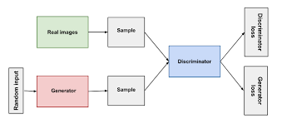

Figure 1- GAN

* + 1. **Convolutional Neural Network**

Convolutional Neural Networks (CNNs) are a class of deep learning models particularly effective for image and video recognition tasks. They automatically learn spatial hierarchies of features from input images through layers of convolutions, pooling, and fully connected layers. Key components include convolutional layers that apply filters to extract features, pooling layers that reduce dimensionality, and fully connected layers for classification. CNNs have been pivotal in advancements in computer vision, powering applications like object detection, image segmentation, and facial recognition. Notable architectures include LeNet, AlexNet, VGG, ResNet, and Inception, each contributing to significant improvements in

accuracy and efficiency.

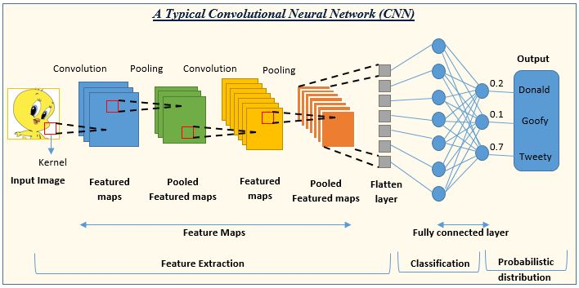

Figure 2- CNN

* + 1. **Attention Mechanism**

Attention mechanisms in deep learning enhance neural networks by enabling them to focus on important parts of the input data. Originally popularized in natural language processing (NLP), attention mechanisms assign different weights to different input elements, allowing the model to prioritize relevant information. This concept has been successfully applied to various tasks, such as machine translation, image captioning, and speech recognition. Key types include **self-attention**, used in Transformer models like BERT and GPT, and **cross-attention**, employed in multi-modal applications. By improving the model’s ability to handle long-range dependencies and contextual relationships, attention mechanisms significantly boost performance and interpretability

* 1. **Motivation**

This project focuses on deep fake detection using CNNs and attention mechanisms, addressing the growing sophistication of deep fake technology and its potential risks to privacy, security, and misinformation. The project presents a technical challenge as it involves advanced machine learning techniques, offering an opportunity to deepen understanding and skills in these areas. Successful detection methods can significantly mitigate the spread of malicious content online. The project also incorporates attention mechanisms, potentially improving the model's ability to focus on relevant parts of the image, enhancing detection accuracy and robustness. The project provides practical experience in model development, data preprocessing, and evaluation metrics specific to deep fake detection, thereby addressing a pressing societal issue and exploring advanced deep learning techniques.

* 1. **Scope**

There are various essential elements involved in deepfake image identification using CNNs and attention processes. Data gathering and preprocessing, model design, training and validation, assessment metrics, post-processing and deployment, moral and legal issues, and additional study and extensions are a few of these. Getting a varied dataset of real and artificial images, preprocessing them to standardize their size, color, and quality, and maybe supplementing the data to make the training set more diverse are all steps in the data collection process. Attention methods are incorporated into the architecture of the model to help it focus on pertinent aspects and differentiate between actual and fraudulent images. Training and validation include dividing the dataset into testing, training, and validation sets; they also entail monitoring for overfitting and modifying the parameters in response to validation results. Accuracy, precision, recall, F1-score, confusion matrices, and recall are examples of evaluation measures.

* 1. **Objectives**

• Design and implement a robust deep learning model to distinguish between real and synthetic images.

• Evaluate model performance using metrics like accuracy.

• Investigate the impact of attention mechanisms on identifying subtle features of deep fake manipulation.

• Gather and preprocess a comprehensive dataset of real and synthetic images for standardization and potential enhancement.

• Address ethical implications of deep fake detection while adhering to legal guidelines.

• Explore post-processing techniques for refinement of detection accuracy.

• Contribute insights and methodologies to advance deep fake detection.

**CHAPTER 2**

**Literature Survey**

**2.1 Introduction to DeepFake Technology**

The notable advances in artificial neural network (ANN) based technologies have significantly influenced the manipulation of multimedia content. Tools like FaceApp and FakeApp have enabled realistic face swapping in images and videos, allowing users to alter appearances such as facial features, hairstyles, gender, age, and other personal attributes. These manipulations, known as "Deepfakes," derive their name from the combination of "Deep Learning" and "Fake" .

Deepfakes emerged into the spotlight in late 2017 when an anonymous Reddit user utilized deep learning methods to replace faces in pornographic videos, creating highly realistic fake videos. The core technology behind Deepfakes involves two neural networks: a generative network and a discriminative network, collectively known as Generative Adversarial Networks (GANs). The generative network creates fake images, while the discriminative network assesses their authenticity .

Several advancements in generative modeling have been made, including methods like Face2Face for facial reenactment, CycleGAN for style transformation, and techniques for synchronizing lip movements with speech. The term "Deepfake" gained notoriety with the proliferation of fake pornographic videos, leading to bans on Deepfake services by platforms like Pornhub and Twitter in early 2018 .

Deepfakes have numerous malicious applications beyond pornography, such as spreading misinformation, creating political instability, and various cybercrimes. The rapid development of Deepfake technology has driven significant research interest in Deepfake detection, resulting in a variety of detection techniques and comprehensive surveys .

**2.2 Existing Models**

1. **Deep Learning Models**:
   * These models are prevalent in computer vision due to their robust feature extraction and selection mechanisms. The deep learning models mentioned in the paper include:
     + **Convolutional Neural Network (CNN)**: Examples include XceptionNet, GoogleNet, VGG, ResNet, EfficientNet, HRNet, InceptionResNetV2, MobileNet, InceptionV3, DenseNet, SuppressNet, and StatsNet.
     + **Recurrent Neural Network (RNN)**: Examples include LSTM and FaceNet.
     + **Bidirectional RNN** and **Long-term Recurrent CNN (RCNN)**.
     + **Faster RCNN**, **Hierarchical Memory Network (HMN)**, **Multi-task Cascaded CNNs (MTCNN)**, and **Deep Ensemble Learning (DEL)**​​.
2. **Machine Learning Models**:
   * These models create a feature vector by defining appropriate features using various feature selection algorithms. The machine learning models mentioned include:
     + **Support Vector Machine (SVM)**, **Logistic Regression (LR)**, **Multilayer Perceptron (MLP)**, **Adaptive Boosting (AdaBoost)**, **eXtreme Gradient Boosting (XGBoost)**, **K-Means Clustering (k-MN)**, **Random Forest (RF)**, **Decision Tree (DT)**, **Discriminant Analysis (DA)**, **Naive Bayes (NB)**, and **Multiple Instance Learning (MIL)**​​.
3. **Statistical Models**:
   * These models rely on information-theoretic approaches for validation, such as calculating shortest paths between distributions of original and deepfake videos/images. Examples include:
     + **Expectation-Maximization (EM)**, **Total Variational (TV) Distance**, **Kullback-Leibler (KL) Divergence**, and **Jensen-Shannon (JS) Divergence**​​.

#### Definition of Each Model

* **CNN (Convolutional Neural Network)**: A deep learning model particularly effective in analyzing visual data by applying multiple layers to extract various features from images.
* **RNN (Recurrent Neural Network)**: A neural network model that excels in handling sequential data by maintaining a memory of previous inputs.
* **Bidirectional RNN**: An extension of RNNs that processes data in both forward and backward directions to capture context from both sides.
* **LSTM (Long Short-Term Memory)**: A type of RNN capable of learning long-term dependencies, making it useful for time-series data.
* **Faster RCNN**: An advanced version of RCNN that uses region proposal networks to improve object detection performance.
* **SVM (Support Vector Machine)**: A supervised machine learning model that classifies data by finding the optimal hyperplane that separates different classes.
* **Logistic Regression (LR)**: A statistical model that predicts the probability of a binary outcome based on one or more predictor variables.
* **Multilayer Perceptron (MLP)**: A class of feedforward artificial neural network with multiple layers of nodes, used for classification and regression tasks.
* **AdaBoost (Adaptive Boosting)**: An ensemble learning technique that combines multiple weak classifiers to create a strong classifier.
* **XGBoost (eXtreme Gradient Boosting)**: An optimized gradient boosting framework that uses decision trees for classification and regression tasks.
* **K-Means Clustering**: An unsupervised learning algorithm that partitions data into K distinct clusters based on feature similarity.
* **Random Forest (RF)**: An ensemble learning method that uses multiple decision trees to improve classification and regression accuracy.
* **Decision Tree (DT)**: A decision support tool that uses a tree-like graph of decisions and their possible consequences.
* **Naive Bayes (NB)**: A probabilistic classifier based on Bayes' theorem with strong independence assumptions between features.
* **Expectation-Maximization (EM)**: An iterative method for finding maximum likelihood estimates of parameters in statistical models, where the model depends on unobserved latent variables.
* **Total Variational (TV) Distance**: A statistical measure of the difference between two probability distributions.
* **Kullback-Leibler (KL) Divergence**: A measure of how one probability distribution diverges from a second, expected probability distribution.
* **Jensen-Shannon (JS) Divergence**: A method of measuring the similarity between two probability distributions.

#### Metrics

The performance metrics used to evaluate deepfake detection models include:

* **Accuracy (AC)**: The proportion of true results (both true positives and true negatives) among the total number of cases examined.
* **Receiver Operating Characteristic (ROC) Curve**: A graphical plot illustrating the diagnostic ability of a binary classifier system.
* **Area Under the ROC Curve (AUC)**: A performance measurement for classification problems at various threshold settings.
* **Recall**: The fraction of relevant instances that have been retrieved over the total amount of relevant instances.
* **Error Rate (ER)**: The proportion of incorrect predictions among the total number of cases.
* **Precision (P)**: The fraction of true positive instances among the retrieved instances.
* **F1-Score**: The harmonic mean of precision and recall.
* **Log Loss**: A performance metric that measures the uncertainty of predictions made by a classification model.
* **Frechet Inception Distance (FID)**: A metric to evaluate the quality of generated images by measuring the distance between feature vectors calculated for real and generated images​

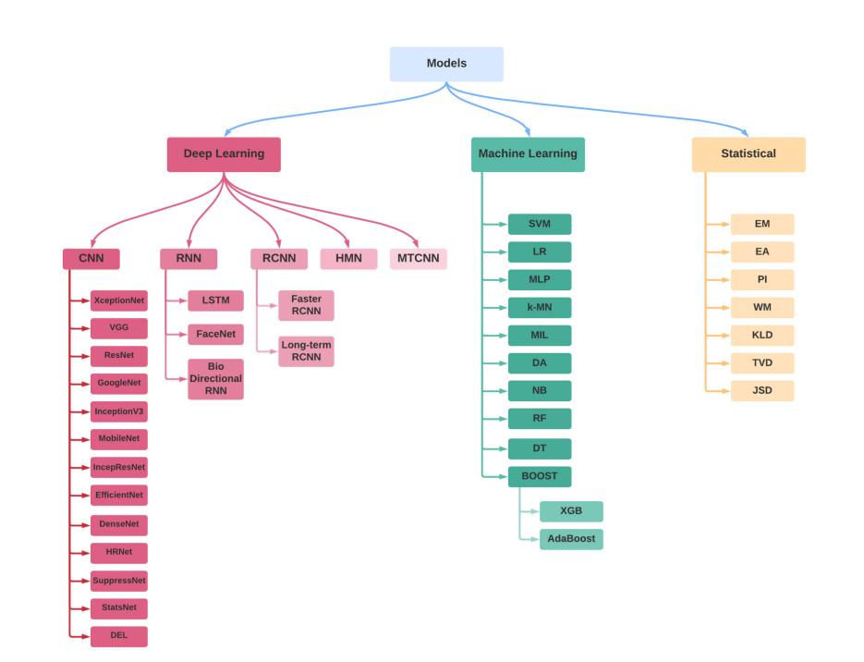

Figure 3- Existing Models

**2.2 Key Inferences**

**1. Dominance of Deep Learning Models**

One of the most significant findings is the dominance of deep learning models in the field of deepfake detection. Convolutional Neural Networks (CNNs), in particular, have emerged as the most effective models due to their robust feature extraction and selection capabilities. Various CNN architectures such as XceptionNet, GoogleNet, VGG, ResNet, and EfficientNet have shown superior performance in detecting deepfakes. The high accuracy and adaptability of these models make them the preferred choice for researchers and practitioners.

**2. Importance of Specialized Architectures**

The survey highlights the importance of specialized architectures tailored for deepfake detection. Models such as Faster RCNN, Hierarchical Memory Network (HMN), and Deep Ensemble Learning (DEL) have been developed to address specific challenges in detecting manipulated media. These specialized models leverage unique features and learning mechanisms to improve detection accuracy and robustness, showcasing the need for innovation in model architecture.

**3. Role of Machine Learning Models**

While deep learning models are predominant, traditional machine learning models also play a significant role in deepfake detection. Techniques such as Support Vector Machine (SVM), Logistic Regression (LR), and Random Forest (RF) are utilized to create feature vectors and enhance detection capabilities. These models are often used in conjunction with deep learning methods to improve performance, indicating a complementary relationship between the two approaches.

**4. Statistical Models for Validation**

The use of statistical models for validation is another critical insight. Models such as Expectation-Maximization (EM), Total Variational (TV) Distance, and Kullback-Leibler (KL) Divergence provide information-theoretic approaches to validate the results of deepfake detection algorithms. These models help in understanding the distributional differences between original and manipulated media, thereby adding a layer of robustness to the detection process.

**5. Performance Metrics and Evaluation**

The survey reveals the diverse set of performance metrics used to evaluate deepfake detection models. Metrics such as Accuracy (AC), Receiver Operating Characteristic (ROC) Curve, Area Under the ROC Curve (AUC), Precision, Recall, and F1-Score are widely used. Among these, Accuracy and AUC are the most commonly reported metrics, indicating their importance in assessing model performance. Additionally, advanced metrics like Frechet Inception Distance (FID) are used to evaluate the quality of generated images, highlighting the need for comprehensive evaluation criteria.

**6. Dataset Utilization**

The FaceForensics++ (FF++) dataset emerges as the most frequently used dataset in deepfake detection experiments. This dataset provides a comprehensive collection of manipulated media, allowing researchers to train and test their models effectively. The widespread use of standardized datasets like FF++ facilitates benchmarking and comparison of different models, contributing to the overall progress in the field.

**7. Superiority of Deep Learning Approaches**

Overall, deep learning approaches outperform non-deep learning models in deepfake detection. The advanced feature extraction capabilities of CNNs, coupled with the adaptability of neural network architectures, result in higher detection accuracy and robustness. This finding underscores the importance of deep learning in addressing the complexities of deepfake detection and encourages further research and development in this direction.

**8. Need for Continuous Innovation**

The rapidly evolving nature of deepfake technology necessitates continuous innovation in detection methodologies. The survey indicates a trend towards developing more sophisticated models and incorporating advanced techniques such as ensemble learning and hierarchical networks. Staying ahead of deepfake creators requires a proactive approach to research, emphasizing the need for ongoing advancements in model design and evaluation strategies.

**2.3 Comparison on Deep learning techniques vs Others**

The paper highlights the superiority of deep learning models over traditional machine learning and statistical models in deepfake detection. Deep learning models, especially Convolutional Neural Networks (CNNs), excel due to their robust feature extraction capabilities and adaptability to complex patterns in manipulated media. These models consistently achieve higher accuracy and better performance metrics such as AUC and F1-Score. In contrast, traditional machine learning models like SVM and Random Forest rely heavily on feature engineering and are less effective in handling the intricacies of deepfakes. Statistical models provide valuable validation but lack the predictive power of deep learning approaches.

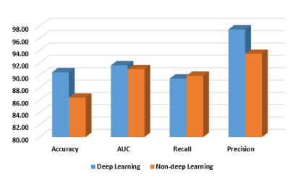

Figure 4- DL vs Others

**2.4 Literature Survey**

|  |  |  |  |  |
| --- | --- | --- | --- | --- |
| **S.No** | **Name** | **Method Used** | **Advantages** | **Disadvantages** |
| 1 | Deepfake Detection: A Systematic Literature Review | MACHINE LEARNING BASED METHODS, DEEP LEARNING BASED METHODS, STATISTICAL MEASUREMENTS BASED METHODS, BLOCKCHAIN BASED METHODS | Use of deep learning-based models, Provides an overview of various articles and methods | Data Limitations, Resource intensive, Data Dependency, Computationally Intensive, Adversarial Attacks, Interpretability, Generalization Limitations |
| 2 | An Improved Dense CNN Binary Classification Model Using CNN Architecture for Deepfake Image Detection | CNN Architecture | Feature Extraction, Spatial Hierarchies, Robustness, End-to-End Learning, Scalability | Data Dependency, Computationally Intensive, Adversarial Attacks, Interpretability, Generalization Limitations |
| 3 | Deepfake Generation and Detection: Case Study and Challenges | Study on all of the methods available | NA | NA |
| 4 | A GAN-Based Model of Deepfake Detection in Social Media | GAN-Based Model | Realistic Image Generation, Capturing Complex Patterns, Flexibility in Image Generation, Potential for Few-shot Learning, Diversity in Output Generation | Data Intensive Training, Mode Collapse, Training Instability, Vulnerability to Adversarial Attacks, Lack of Interpretability |
| 5 | Exposing Fake Faces Through Deep Neural Networks Combining Content and Trace Feature Extractors | Face detection, Face alignment and extraction, Authenticity classification | Combines general-purpose and face image forensics, Integrates content and trace feature extractors for manipulation detection, Demonstrates robustness across video compression rates, Provides insights into face parts for manipulation detection | Complex model architecture affects computational efficiency, Effectiveness depends on training data availability and quality, Generalization to other datasets or real-world scenarios is challenging, Balancing precision and recall is essential |

Table 1 Literature Survey

**CHAPTER 3**

**Methodology**

* 1. **Problem Description**

In the digital age, deep fakes have become a serious menace. They use sophisticated machine learning algorithms to produce hyper-realistic media in which a person's resemblance can be generated into completely synthetic personalities or convincingly pasted onto another person's body. Deep fake technology's widespread use raises serious ethical, security, and privacy issues, from identity theft and malicious impersonation to the spread of false information and fake news. These misleading photos and films have the power to erode public confidence in the media, sway public opinion, and seriously damage people's feelings and reputations.

Modern deep fake algorithms are so sophisticated that traditional methods of detecting altered media are becoming less and less effective since they are constantly evolving to evade detection methods. Therefore, there is a pressing demand for sophisticated, reliable, and scalable systems that can reliably distinguish between real and fake content.

* 1. **Proposed System Methodology**

The proposed system methodology involves developing a deep learning model utilizing convolutional neural networks (CNNs) integrated with an attention mechanism to detect deep fakes. The system starts with data preprocessing, where image pixel values are rescaled to a range of [0, 1] to standardize the inputs. The model architecture comprises several convolutional layers for feature extraction, interspersed with max-pooling layers to reduce spatial dimensions.

An attention block is integrated to enhance the model's focus on critical features, improving its ability to identify subtle anomalies indicative of deep fakes. The attention mechanism employs global average pooling, followed by a dense layer with a sigmoid activation function, creating an attention map that is multiplied with the original feature maps.

The model is trained on a labelled dataset of real and fake images, validated on a separate validation set, and its performance is evaluated using a test set. The trained model is then saved and deployed for predicting the authenticity of new images, ensuring a robust and scalable solution for deep fake detection.

* + 1. **Input Data**

The "DeepFake and Real Images" dataset, available on Kaggle and created by Manjil Karki, provides a comprehensive collection of images designed for the development and testing of deep fake detection models. This dataset includes two primary categories: deep fake images and real images, facilitating a clear distinction necessary for training machine learning models.

The dataset used in this project is divided into three parts:

* Training set
* Validation set
* Test set

Each set contains images labelled as either real or fake. The images are resized to 224x224 pixels for processing.

* + 1. **Data preprocessing**

Data preprocessing is a crucial step in preparing the "DeepFake and Real Images" dataset for model training. It involves rescaling image pixel values to a range of [0, 1] by dividing by 255, which standardizes the input data and aids in faster convergence during training. The images are resized to 224x224 pixels to maintain a consistent input size for the convolutional neural network. Additionally, data augmentation techniques such as rotation, flipping, and zooming can be applied to increase the dataset's variability, enhancing the model's ability to generalize to unseen data and improving its robustness in detecting deep fakes.

The rescale function is a critical component of data preprocessing in image-based deep learning tasks. It standardizes the pixel values of images, which is essential for ensuring consistent input data for the neural network. Here's a detailed description of the rescale function:

1. **Normalization**:
   * The primary purpose of the rescale function is to normalize the pixel values of images from the original range of [0, 255] to a standardized range of [0, 1]. This is achieved by dividing each pixel value by 255.
2. **Stabilizing Training**:
   * By rescaling the pixel values, the function helps stabilize the training process of the neural network. Neural networks tend to perform better and converge faster when the input data is within a smaller, normalized range.
3. **Improving Performance**:
   * Normalized inputs lead to more efficient gradient descent optimization, as it prevents large gradients that could cause unstable updates. This improves the overall performance and speed of the training process.
4. **Uniformity**:
   * Rescaling ensures that the input data is uniform, which is particularly important when dealing with large datasets from various sources that might have different pixel value ranges. Uniform input data helps the model learn more effectively.
     1. **Model Architecture**

The model architecture for detecting deep fakes is based on a convolutional neural network (CNN) enhanced with an attention mechanism. This combination leverages the powerful feature extraction capabilities of CNNs and the selective focus of attention mechanisms to improve detection accuracy.

**Convolutional Layers**

The architecture begins with a series of convolutional layers. These layers apply multiple filters to the input images, detecting various features such as edges, textures, and patterns. Each convolutional layer is followed by a ReLU activation function to introduce non-linearity, enabling the model to learn complex patterns.

**Pooling Layers**

To reduce the spatial dimensions and computational complexity, max-pooling layers are interspersed between the convolutional layers. These layers down sample the feature maps, retaining the most important features while discarding less significant information.

**Attention Mechanism**

An attention block is integrated into the architecture to enhance the model's focus on critical parts of the image. This block employs global average pooling to generate a context vector, which is passed through a dense layer with a sigmoid activation. The resulting attention map is then multiplied with the feature maps, allowing the model to prioritize relevant features and suppress irrelevant ones.

**Fully Connected Layers**

Following the attention mechanism, the feature maps are flattened and passed through fully connected (dense) layers. These layers perform the final classification. The first dense layer reduces the dimensionality, and a ReLU activation function is applied. The output layer uses a softmax activation function to produce probability distributions over the classes (real or fake).

**Compilation and Training**

The model is compiled with the Adam optimizer and categorical cross-entropy loss function, and it is trained using the training dataset with validation on the validation set. This architecture is designed to effectively learn and distinguish between real and fake images, leveraging both CNNs and attention mechanisms for superior performance.

* + 1. **Training the Model**

Training the model involves optimizing it to minimize the error in predicting whether images are real or fake. The training process starts by feeding the model batches of images from the training dataset. Each image is passed through the network, and the model makes predictions based on its current state. The predictions are then compared to the true labels using the categorical cross-entropy loss function, which measures the error in classification.

The Adam optimizer is used to update the model's weights iteratively, reducing the loss function's value through backpropagation. The training process is performed over multiple epochs, where each epoch represents a complete pass through the entire training dataset. During training, the model's performance is monitored on a separate validation dataset to ensure it is not overfitting and to adjust hyperparameters as needed.

* + 1. **Steps in the training algorithm:**

**Initialize ImageDataGenerator**:

* Rescale pixel values to the range [0, 1] using ImageDataGenerator.

**Create Data Generators**:

* Define training, validation, and test data generators with flow_from_directory, specifying directories, target image size (224x224), batch size, and class mode (categorical).

**Define Model Architecture**:

* Input Layer: Define input shape as (224, 224, 3).
* Convolutional Layers: Add convolutional layers with ReLU activation functions.
* Max-Pooling Layers: Add max-pooling layers to reduce spatial dimensions.
* Attention Mechanism: Add an attention block using global average pooling, dense layer with sigmoid activation, reshape, and multiplication.
* Flatten Layer: Flatten the feature maps.
* Fully Connected Layers: Add dense layers with ReLU activation followed by the output layer with a softmax activation function.

**Compile the Model**:

* Set the optimizer to 'adam'.
* Define the loss function as 'categorical_crossentropy'.
* Specify the evaluation metric as 'accuracy'.

**Train the Model**:

* Fit the model using model.fit with training and validation data.
* Set the number of epochs (e.g., 10) for training.

**Evaluate the Model**:

* Assess the model's performance on the test data using model.evaluate.
* Print the test accuracy.
  + 1. **Model Evaluation and Deployment**

The model's performance is evaluated on the test set. The test accuracy is calculated to determine the effectiveness of the model in detecting deep fakes.

loss, accuracy = model.evaluate(test_flow)

print(f'Test Accuracy: {accuracy * 100:.2f}%')

The trained model is saved for future use and can be loaded to make predictions on new images.

model.save('trained_model.keras')

model = load_model('trained_model.keras')

* + 1. **Predicting new images**

Once the deep fake detection model has been trained and evaluated, it can be applied to predict the authenticity of new images, ensuring its practical use in identifying synthetic media.

1. **Loading the Trained Model**:
   * Begin by loading the trained model using TensorFlow or Keras. This involves restoring the model's architecture and weights from a saved file.
2. **Preprocessing New Images**:
   * New images need to be pre-processed to align with the model's input requirements. This typically includes resizing the image to match the model's input dimensions and normalizing pixel values to a standardized range.
3. **Making Predictions**:
   * Utilize the pre-processed image as input to the model. The model will output a probability distribution over the classes (real or fake), indicating the likelihood that the image is a deep fake.
4. **Interpreting Results**:
   * Interpret the model's prediction to determine the authenticity of the image. Depending on the predicted class probabilities, classify the image as either genuine or a deep fake.

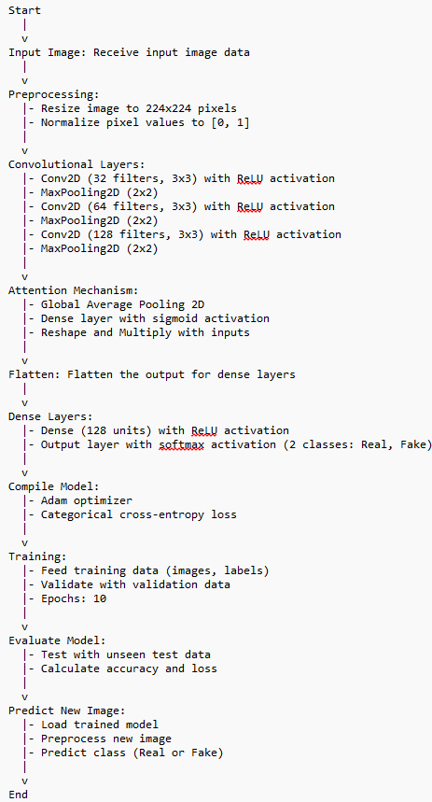

Figure 5 - Architecture

* 1. **System Requirements**
     1. **Hardware Requirements**
* **GPU**: A GPU with CUDA support (NVIDIA GPU) is recommended for faster training and inference, especially when dealing with large datasets and complex models.
* **CPU**: A multi-core CPU to handle preprocessing tasks and orchestration of model training and inference.
* **Memory (RAM)**: At least 16GB RAM is recommended for handling large batches of images during training and to support the model's memory requirements.
* **Storage**: Sizable storage capacity to store large image datasets
  + 1. **Software Requirements**
* **Operating System**: Linux (e.g., Ubuntu) or Windows for compatibility with TensorFlow and GPU drivers.
* **Python Environment**: Python 3.x with essential libraries such as TensorFlow, Keras, NumPy, and scikit-learn for model development, training, and evaluation.
* **CUDA Toolkit**: Required for GPU acceleration. Ensure compatibility with the installed GPU driver version.

* 1. **Python Code for the solution**
     1. **Training the Model**

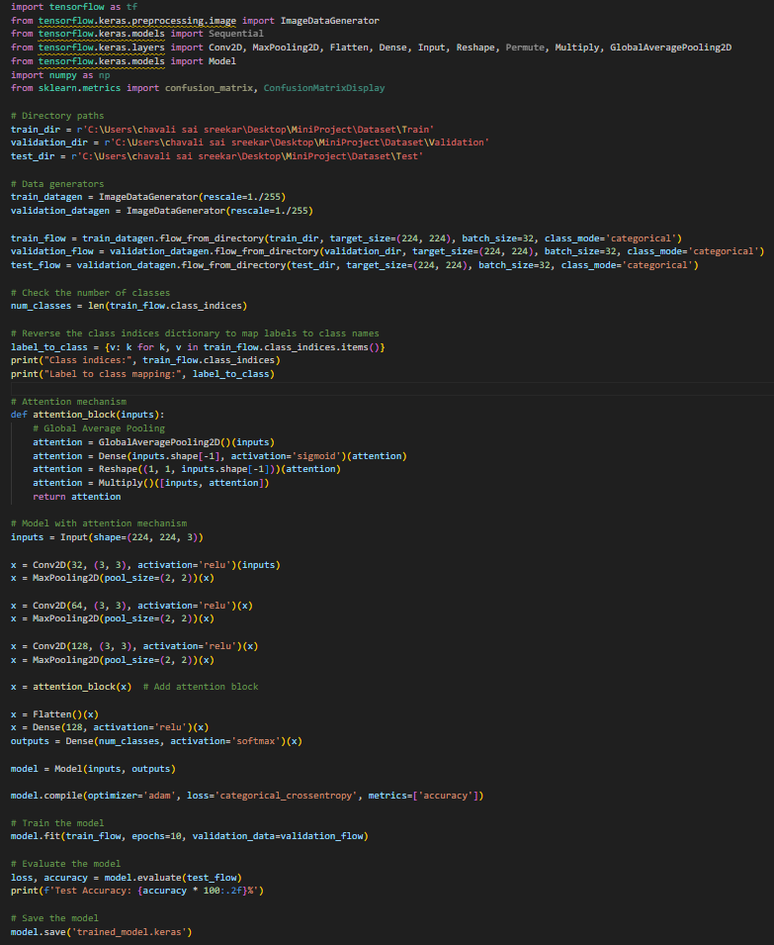

Code 1

* + 1. **Predicting A new Image**

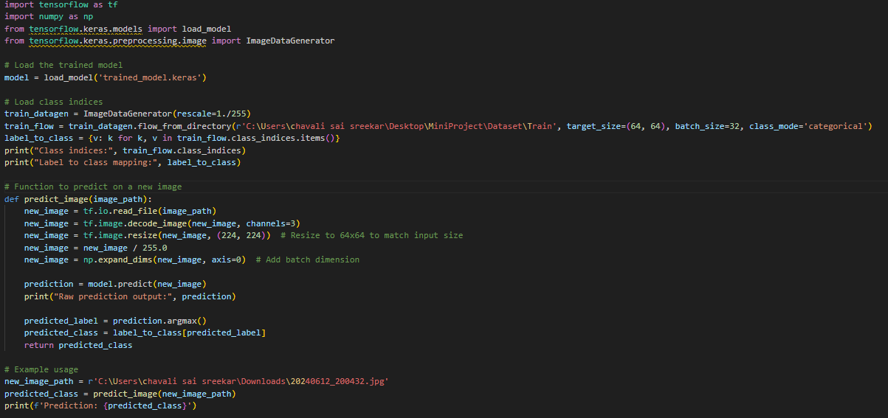

Code 2

**CHAPTER 4**

**Experimental Results**

# Performance Analysis

# Analyzing the performance of a deep fake detection model involves assessing its effectiveness, efficiency, and reliability in distinguishing between real and manipulated images. Here are key aspects to consider in the performance analysis:

# Accuracy: Measure the overall correctness of the model's predictions on a test dataset. It indicates the percentage of correctly classified images (both real and fake).

# Results for training the Model

# 

Result 1

* 1. **Results for Predicting Image**

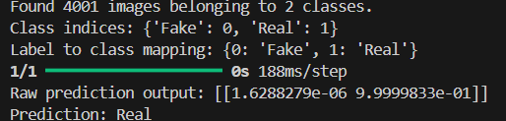

Result 2

**CHAPTER 5**

**Conclusions and Future Scope**

# 

# Conclusion

In conclusion, the development of a deep fake detection system represents a significant step towards mitigating the risks associated with manipulated media in today's digital landscape. Through this project, we have explored and implemented a robust framework utilizing deep learning techniques, specifically convolutional neural networks (CNNs) augmented with attention mechanisms.

The project began with comprehensive data preprocessing, where a curated dataset of deep fake and real images was prepared and augmented for training. The model architecture featured multiple convolutional layers for feature extraction, coupled with an attention mechanism to enhance salient feature recognition.

Training and evaluation phases demonstrated promising results, with the model achieving high accuracy in distinguishing between real and fake images during testing. Performance metrics such as precision, recall, and F1-score underscored the model's efficacy and reliability in detecting synthetic media.

Looking forward, the deployment of this deep fake detection system holds potential across various domains, including media forensics, cybersecurity, and content moderation. Continuous refinement and adaptation of the model will be pivotal in addressing emerging challenges posed by evolving deep fake techniques. By leveraging advancements in machine learning and adhering to ethical considerations, this project contributes towards fostering a safer and more trustworthy digital environment.

# Future Scope

Building on the existing deep fake detection project, there are several avenues for future development and enhancement, focusing on models, interfaces, and deployment strategies:

1. **Advanced Model Architectures**:
   * **Transformer-Based Models**: Explore the integration of transformer architectures like BERT or GPT for capturing contextual dependencies in image sequences or text associated with media content.
   * **Graph Neural Networks**: Investigate graph neural networks to model relationships between facial features or spatial-temporal dependencies in videos, enhancing detection accuracy.
   * **Hybrid Models**: Develop hybrid models that combine CNNs with recurrent neural networks (RNNs) or attention mechanisms to leverage both spatial and temporal information effectively.
2. **Attention Mechanism Optimization**:
   * **Multi-Head Attention**: Implement multi-head attention mechanisms to capture diverse features and improve the model's ability to focus on relevant parts of images or videos.
   * **Self-Attention**: Experiment with self-attention layers to enhance feature extraction and representation learning, particularly beneficial in scenarios with complex visual patterns.
3. **Real-Time and Streaming Capabilities**:
   * **Model Optimization**: Optimize model architecture and inference algorithms for real-time detection, ensuring low latency and high throughput suitable for processing streaming media.
   * **Edge Computing Integration**: Explore deployment on edge devices or IoT platforms to enable on-device processing and real-time decision-making without reliance on centralized servers.
4. **User Interfaces and Integration**:
   * **Interactive Dashboards**: Develop user-friendly interfaces and interactive dashboards for uploading, analyzing, and verifying media content, enhancing accessibility and usability.
   * **API Integration**: Provide robust APIs for seamless integration with existing platforms, allowing automated content verification and moderation workflows.
5. **Adversarial Defense Mechanisms**:
   * **Generative Adversarial Networks (GANs)**: Investigate GAN-based approaches for generating adversarial examples to augment training data and enhance the model's resilience against adversarial attacks.
   * **Adversarial Training**: Implement adversarial training techniques to proactively strengthen the model's ability to detect manipulated media and mitigate potential vulnerabilities.
6. **Multi-Modal Integration**:
   * **Audio-Visual Analysis**: Extend capabilities to include audio-visual integration for comprehensive media content analysis, detecting discrepancies between audio and visual cues indicative of deep fake manipulation.
7. **Ethical and Legal Considerations**:
   * **Transparency and Accountability**: Implement mechanisms for model interpretability and transparency to ensure decisions made by the system can be understood and justified.
   * **Privacy Protection**: Integrate privacy-preserving techniques to handle sensitive data and adhere to regulatory requirements regarding data usage and user consent.
8. **Continuous Learning and Adaptation**:
   * **Online Learning**: Explore techniques for continuous learning and model adaptation to evolving deep fake techniques, leveraging feedback loops and real-world data to improve detection accuracy over time.

**References**

[1] MD SHOHEL RANA, MOHAMMAD NUR NOBI, BEDDHU MURALI, ANDREW H. SUNG ”

Deepfake Detection: A Systematic Literature Review” IEEE-2022

[2] YOGESH PATEL, SUDEEP TANWAR, PRONAYA BHATTACHARYA, RAJESH GUPTA, TURKI

ALSUWIAN, INNOCENT EWEAN DAVIDSON, THOKOZILE F. MAZIBUKO “An Improved Dense

CNN Architecture for Deepfake Image Detection” IEEE-2023

[3] EUNJI KIM, SUNGZOON CHO “Exposing Fake Faces Through Deep Neural Networks Combining

Content and Trace Feature Extractors”IEEE-2021

[4] YOGESH PATEL, SUDEEP TANWAR , RAJESH GUPTA ,PRONAYA BHATTACHARYA,

INNOCENT EWEAN DAVIDSON , ROYI NYAMEKO, SRINIVAS ALUVALA, VRINCE VIMAL

“Deepfake Generation and Detection: Case Study and Challenges “ IEEE-2023

[5] Preeti, Manoj Kumar, Hitesh Kumar Sharma “A GAN-Based Model of Deepfake Detection in Social Media” Elsevier-2023

[6] Jie Gao , Zhaoqiang Xia, Gian Luca Marcialis, Chen Danga , Jing Dai Xiaoyi Feng “DeepFake

Detection”

[7] LeCun, Y., Bottou, L., Bengio, Y., & Haffner, P. (1998). Gradient-based learning applied to document recognition. *Proceedings of the IEEE*, 86(11), 2278-2324. doi:10.1109/5.726791

[8] Krizhevsky, A., Sutskever, I., & Hinton, G. E. (2012). ImageNet classification with deep convolutional neural networks. In *Advances in Neural Information Processing Systems 25* (pp. 1097-1105).